Rumble Through the Jungle Instructions for Meet Day

Race Schedule
A specific division and wave schedule will be distributed separately to all coaches.

Meet Day Updates
Follow us on Twitter @NorthRumble for any race-day updates, including pictures, video, and results.

Directions to the Nature Preserve
PLEASE DO NOT ARRIVE AT THE VENUE MORE THAN ONE HOUR BEFORE YOUR DIVISION IS SCHEDULED TO BEGIN.

Gene Snyder Freeway (I-265) north to US 42 exit (last exit before the toll bridge). Turn right and follow 5.5 miles east to the traffic light at Hwy 1793. Continue east on US 42 past Highway 1793 0.5 miles and turn left on Harmony Landing Road. Follow 0.3 miles back to the Nature Preserve and volunteers will direct you to the parking areas. Our traffic flow is restricted to one way into the Nature Preserve.

We will restrict the traffic flow to one way into the Nature Preserve. The entry into the Nature Preserve is through the city of Goshen. DO NOT TRY TO ENTER THE NATURE PRESERVE FROM HWY 1793. PASS THIS ALONG TO YOUR PARENTS. Please be respectful of the speed limit (20 mph) and all stop signs. This is a heavily populated neighborhood, with lots of children. The speed limit and stop signs are there for the safety of everyone. Police may be present and they will issue citations for speeding and rolling stops, so please warn your parents and fans. Exiting traffic is to KY 1793.

Handicapped parking is available. Please alert the parking attendants of any special parking requirements.

Mask Policy (IMPORTANT. PLEASE RELAY TO ALL POTENTIAL SPECTATORS)

ALL persons in attendance at the Rumble are required to wear a mask at all times, including runners, coaches, spectators, volunteers, and officials. The only exception is runners during actual competition. This means runners must wear a mask to warm up (KHSAA guideline). Runners may remove their mask when they go to the start line for their race. Masks should be put back on when their race is over.

The mask policy follows state and county department of health regulations and KHSAA guidelines. It is not political; it is simply the only way we are allowed to host this event. Anybody not wearing a mask will be asked to put one on or leave the event. Attendance at Rumble is voluntary. If you don’t want to wear a mask, please don’t come. Do not make our volunteers become the mask police. Any disruptions in this area will result in your team not being invited back to the Rumble next year.

Health Screening

All coaches and athletes will be screened for temperature and COVID symptoms when entering the team gate. A form is attached below for coaches and athletes to fill out ahead of time. Please fill in all information except the temperature. We will take temperatures and record them at the gate. If you are exhibiting symptoms or have a fever, you will not be allowed to enter or compete.

Contact Tracing Information

By health department regulation, we must collect information for contact tracing. We will need to collect name, phone, and email from all persons entering the meet. Please use the Google form at the link below to submit this information online ahead of time to save time at the gate. Take a few minutes at practice before meet day to have your athletes do this and also pass along to spectators. You can use the link or the QR code. Spectators should save the confirmation email to show at the gate. The QR code will also be posted outside the admission gate.

https://docs.google.com/forms/d/e/1FAIpQLSf3Ggyeln9FhVBHJBhva4JbZJU5x00bkgrwEnEGxL1yLVzZMg/viewform?usp=sf_link

Buses
No team buses will be allowed at Rumble for 2020. This is for safety reasons to minimize congregating in groups and athletes length of stay on site.

Tents
No team tents will be allowed at Rumble for 2020. This is for safety reasons to minimize congregating in groups and athletes length of stay on site.

Inclement Weather Plan
If it rains on meet day, we will run in the rain. However, if we have a lightning delay we will direct everybody to cars until it is safe to resume. In this case, our restart plans will be announced via the Twitter handle @NorthRumble, so you can follow that account for updates, and pass to your parents so that they can be informed as well. By rule, we cannot resume competition until 30 minutes after the last sound of thunder. If the meet is delayed, we will make every effort to get all the races in.

Spectators/Admission Fee
Spectators are limited to 2 per family. This is what the Oldham County Health Department has approved. Please respect our crowd size limits.

There will be a $5 admission fee for spectators. Children 5-under will be free. Please let your runners’ parents know ahead of time.

Lost and Found
We will concentrate all lost and found items in the fieldhouse on race day. The fieldhouse is the white building next to the finish area.

Meet Procedures and Traffic Flow

The instructions below refer to this picture:
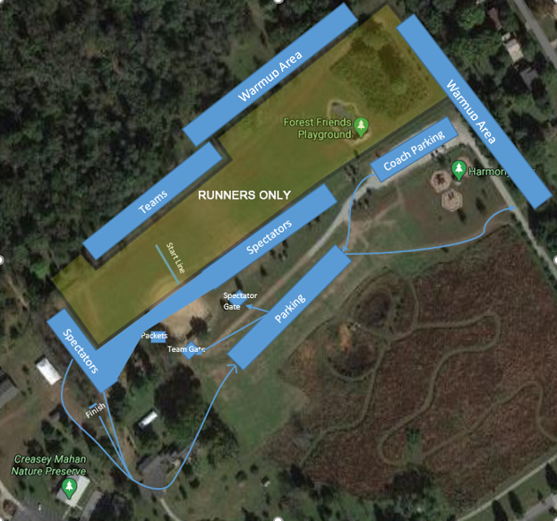

Parking
Coaches will park in the gravel lot by the playground where we usually park buses. Spectators will park in the grass lot marked on the picture.

Teams
PLEASE DO NOT ARRIVE AT THE VENUE MORE THAN ONE HOUR BEFORE YOUR DIVISION IS SCHEDULED TO BEGIN.

If a team is scheduled in multiple divisions due to numbers, only the runners in the current division should be on-site during their division. Teams cannot stay to watch other divisions run.

Teams will use the team gate by the baseball field. At this gate:
- Health screening forms will be turned in and temperatures will be taken
- Coaches will receive a wristband so they can enter the team area and re-enter later sessions. Note to coaches and runners: There will be NOBODY in the woods this year, including coaches or athletes warming up. Coaches will be able to see their athletes in the main field and in the break in the woods behind the warmup area. We just can’t have people scattered in the woods this year.
- After entering the gate, coaches will pick up number packets self-serve by the baseball left field dugout.

Once through the gate, teams should proceed across the field to the team area. We will have number designated team areas for each team in the current division. You will receive your team area number at the same time you receive your division and wave schedule. Athletes should arrive as ready to run as possible and carry as little to the team area as possible. Runners will not be going back to the team area after their race.-------------------------------------------------------------------------------------------------------------------------------------/

Warmups can take place in the main start field until the first wave starts. After that, warmups will be limited to the areas indicated on the picture (behind the team areas and at the far end along the fence).

Bins will be provided in each team area where runners can put their clothing/shoes. During the race, the bins will be carried to the small parking lot by the main house, where runners will retrieve their belongings. Again, please wear/take as little to the team area as possible to minimize what has to be transported.

Garbage bags will be provided at the team areas for water bottles, etc. Please don’t make a mess since we have to clear the area between each division.

We will have several wave lines behind the starting line. As one wave leaves, the next wave can step up and take runouts. Runners MUST run in their assigned wave in order to have a result. You cannot swap runners between waves if they are late, etc. If they are in the wrong wave, they will not be in the results, and we will not try to hunt them down.

Do not carry anything to the starting line you are not running with. Do not leave anything on the ground at the start line. Bottled water will be available at the finish.

After finishing their race, all runners will exit the finish corral and walk straight around the main house, get their gear from the bins, go to their car, and leave the venue. No post-race team meetings, chats with coaches, etc. We must clear the venue before the next division can come in. Coaches that need to stay for more than one division will need to return to their car between divisions so we can make sure the venue is cleared.

Spectators
Spectators will enter through the marked spectator gate. To gain admission, you will need to be wearing a mask, pay the admission fee, and show the emailed receipt that you submitted your contact tracing information.

Spectators will be restricted to the areas marked on the picture above. This is where tent city usually is and the area along the finish stretch. No spectators will be allowed in the team area or the woods. After entering the gate, all spectators should initially go to the area to the right of the baseball field. This is to keep them separated from the entering teams. Once the waves have started, spectators may migrate to the finish area. As their runners finish, spectators should exit past the finish line, around the main house, return to their car, and leave the venue (see the picture above). We must clear the venue before the next division can come in.

It is against KHSAA rules to allow dogs on the course. Our gate workers will be instructed not to admit dogs through the gates. Please pass this along to your parents. Do NOT bring your pets!

COVID-19 Temperature Check and Symptom Screening

This form should be completed and brought to the Rumble by ALL participating runners and coaching staff.

Please check yes or no if you have experienced any of the following symptoms in the last 14 days:

 | Yes | No
Cough
Shortness of Breath
Fever
Chills
Muscle Pain
Sore Throat
New Loss of Taste or Smell

Is there anyone in your household who is showing the symptoms of COVID-19 listed above or has been diagnosed with COVID-19?

Yes
No

Have you been in contact with anyone who is exhibiting the symptoms of COVID-19 above who has not been tested or is awaiting test results?

Yes
No

Temperature:

Signature:

Printed Name: ________________________________

